AI HUMAN CAPITAL AND THE FUTURE OF WORK:

A PRIVACY-PRESERVING LOCAL PERSONAL

AI ASSISTANT

Prachi Sahu, Anshika Singh and Adesh Trivedi

Bachelor of Computer Applications

Allenhouse Business School

Kulgaon Rd, Chakeri Ward, Rooma, Kanpur, Uttar Pradesh 209402

(prachisahu229@gmail.com, singhanshika15665@gmail.com, adeshtrivedi49@gmail.com)

Mr. Deepak Kumar Singh

bca.deepak@allenhouse.ac.in

Department of Computer Science

Allenhouse Business School

Kulgaon Rd, Chakeri Ward, Rooma, Kanpur, Uttar Pradesh 209402

Abstract

It is a first Ai assistant will run on your laptop with minimum requirement. Our solution differs significantly from previous cloud-based AI systems, as it performs all user data processing on the device itself; sensitive information will never leave the device or become disclosed to any external servers or other parties. The assistant will take advantage of on-device large language models, such as Ollama, to run direct inference on the user’s hardware by focusing on lightweight architecture and efficient management of the computational resources. The assistant will support a variety of local tasks independent of the internet, such as file search, document reading, note summarization, and workflow automation. By this design, this project puts data

sovereignty, privacy preservation, and user-controlled intelligence in focus. We are committed to giving users a safe, private, offline-capable personal Ai assistant that upholds high usability while protecting user data and independence

1.INTRODUCTION

1.1 Rise of On-Device AI

Recently, artificial intelligence has experienced tremendous growth, particularly in the area of mobile and edge computing. Prior to the recent developments, the use of artificial intelligence needed the presence of cloud servers, which were responsible for the processing of data from the user and the production of the resultant outputs. Nonetheless, the development of advanced mobile processors, neural processing units, and optimized artificial intelligence frameworks has made it plausible to implement

complex artificial intelligence models on mobile devices. This approach, known as on-device artificial intelligence, has presented substantial benefits in terms of response times, internet connectivity, and privacy.

1.2 Privacy Issues in Cloud-Based AI Assistants(concept-level)

The meaning of Privacy issues, how user data is collected, transmitted, stored, and accessed and what type of risk will be phased. In the context of AI assistants, privacy becomes a concern user personal information such as voice commands, conversations, location, and device
activity leaves the user’s device and is processed on cloud servers.

Cloud-based AI assistants typically operate by recording user inputs (speech or text), sending this data to remote servers, performing models that take decisions on the basis of data, and returning a response. During this pipeline, the data travels across networks and gets stored temporarily or permanently on third-party systems for analysis, model training they can train new and advance models.

AI assistants create several privacy risks. First, users ave control but everyone don’t know how to handle and some time like boring to repeat same process again and again and but they know ? how their personal data is stored and for how long. Second, cloud storage introduces risk to data breaches, sometimes company phasing any cyber attack, or misuse by third-party analytics and advertising systems. since users cannot fully verify what information is collected or how it is used, transparency and trust is very difficult to maintain. As a result, cloud-based AI assistants raise significant doubts regarding data confidentiality, ownership, and user self-determination 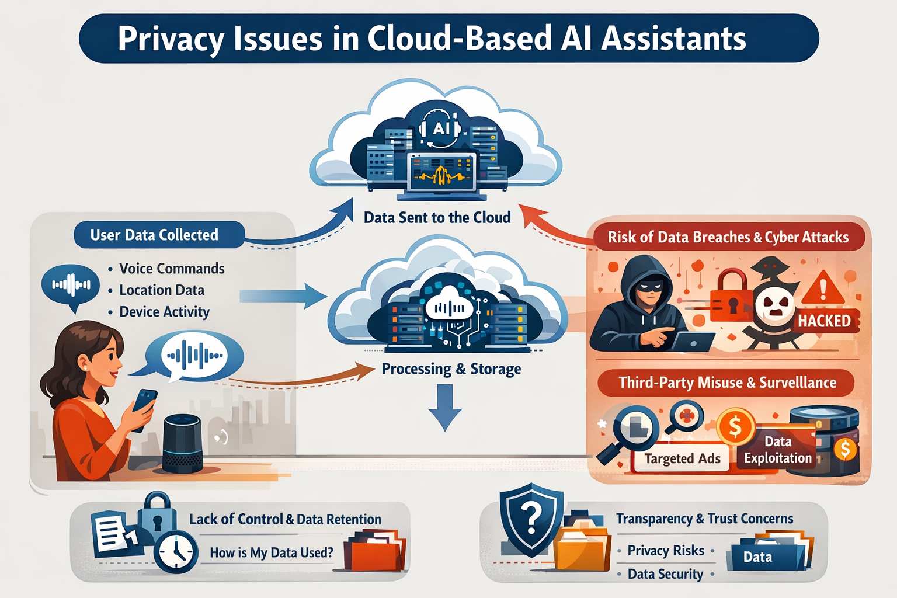

1.3 Need for Local-First Personal Assistants

The rising concerns about privacy and dependence on the availability of

internet connectivity point towards the need for local-first personal assistants. Local-first assistants deal with all the computations right on the machine used by the user in such a way that private data is not sent outside of the machine in any case. Using a local first assistant offers improved privacy as well as a faster and more reliable system to its users. Local first assistants also come in handy in cases where there is a lack of internet connectivity. The need for local first assistants has been triggered by the demands for privacy, control of user’s data by themselves, and offline support.
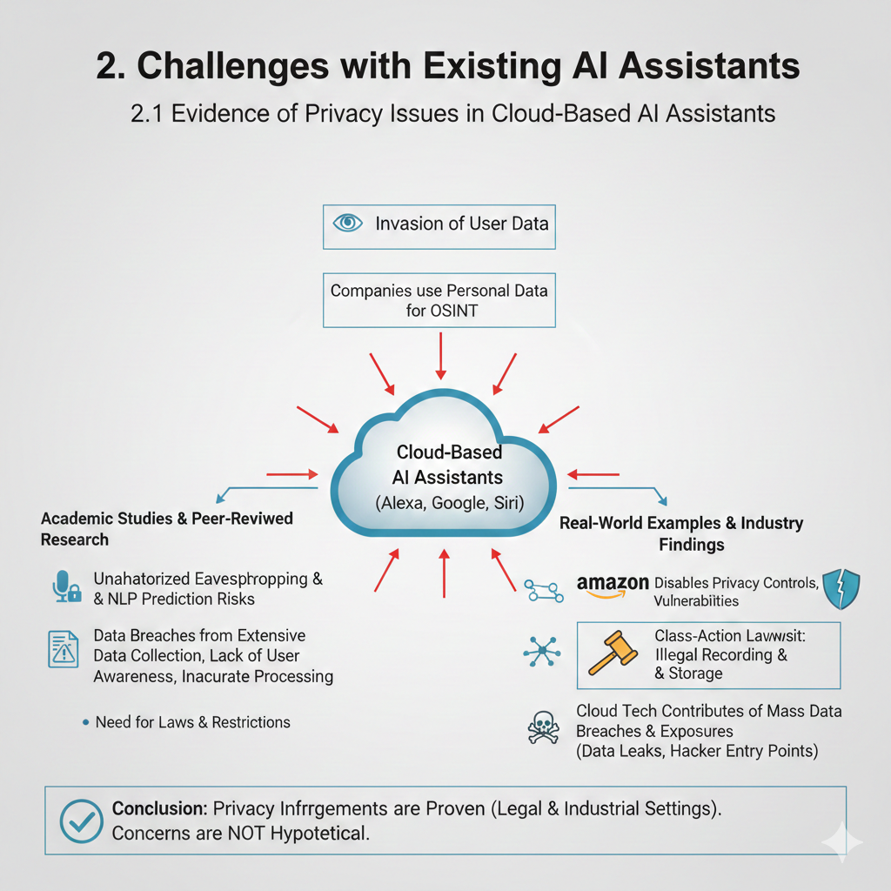2.2 Latency and Internet Dependence

This means cloud-based AI assistants need connectivity to the internet at all times to work effectively. The users' inputs are initially linked to a remote server, where they are then processed and returned as responses. Because these assistants depend on network

connectivity, this will result in delay, particularly if the internet is poor. High latency degrades user experience and results in sluggish responses. In critical, real-time scenarios, this delay can be dangerous. Furthermore, dependency on a firm internet connection makes the assistant irresponsible during weak or lost connectivity. Thus, delay and dependence on the internet are some of the highest limitations for existing AI assistants.

2.3 Limited User Control and Ownership

The user with cloud-driven AI assistants, the data of the users is stored on servers which are owned by companies. This leads to issues of data ownership because cloud-driven assistants do not enable the users to control their data entirely. The data could be utilized for purposes of marketing, analysis, or even sold to other companies without the knowledge and consent of the users. The users also do not have the capacity to control their data entirely. This lack of transparency of data storage and use leads to a loss of trust in AI assistants.
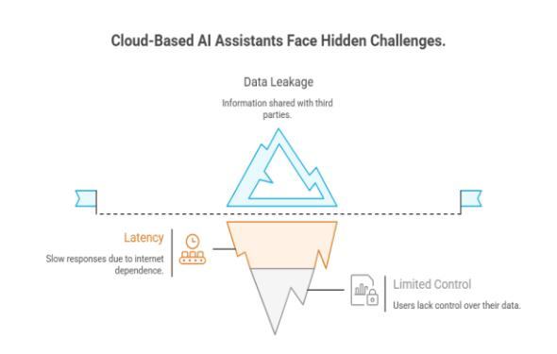

- Local-First AI Assistant: Concept Overview

3.1 Design Philosophy
The design philosophy for a local-first AI assistant is based on a paradigm of privacy by design. Unlike a cloud assistant service, a local-first assistant performs all operations on the user’s machine, so that personal data is not transmitted or routed outside the user machine in the cloud to be compromised. The design intent is centered on user trust, security, and privacy. The design architecture is based on being modular and scalable so that different modules for different functionalities can operate independent but integrated seamlessly with other operations. Also, the design philosophies focus on offline operations for a user to ensure facility availability on a disconnected internet service.
3.2 Key Object

In the local-first design of an AI assistant, the key aims are:

Privacy Preservation:

•Make sure to all user data is processed on the local machine instead of sending any privacy-sensitive data to external servers. Offline Functionality:

•It should provide necessary assistant functions even when there is no internet connection.

Fast Response Time:

•Removing the need for data transfer outside servers makes it possible for tasks to be completed faster with less latency.

User Control:

•Provide users with authority over their personal data to enable them to manage, delete, or limit access to it as required.

Efficient Resource Use:

•Make sure the assistant works well in devices with limited processing and memory.

The above objectives form a guideline in achieving a system that keeps its assistant friendly, secure, and efficient in its operations.

3.3 Target Use Cases

Local-first AI assistants can be employed in the following fields of real life:
•Personal Productivity: Note management, reminders, and scheduling without cloud services.

•Education: Summarizing study material, organizing notes, and assisting in learning tasks offline.

•Business & Office Work: Performing quick searches of documents, summarizing documents, and automating routine tasks.

•Healthcare-locally manage sensitive patient data securely, and maintain confidentiality regarding patient compliance.

•Travel & Remote Areas: Can provide aid when internet access is not available; for example, in the most remote of locations.

•These use cases emphasize the practical utility value of local-first assistants and how they can improve the user experience through providing privacy, speed, and reliability.
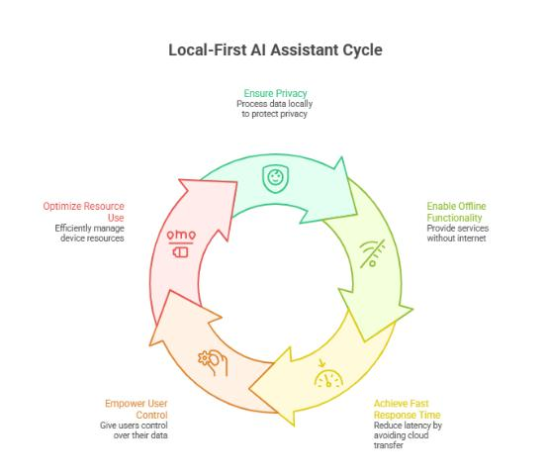

4. System Architecture

4.1 Local Model Layer

The Local Model Layer is the main part of this system, which handles and generates responses that resemble those of a human. In a local-first assistant, the language model is executed on an everyday device, meaning there is no cloud computing involved. The Local Model Layer houses an efficient language model designed for local inference. The language model is able to accomplish NLU, intent detection, and generation of an answer to any user query. The language model handles user queries by employing its knowledge to produce an answer accordingly.

4.2 Level of Management

Task Handling Layer: It serves as the coordinator of the system and handles all the requests from the users to direct them to their corresponding functional modules and tasks based on their execution and priorities. It receives the query from the users and comprehends the task of which kind it is: file searching, document summarization, note organization, and task automation. It takes care of the flow of tasks by ensuring that the tasks are performed by the system with efficiency and correctness.

4.3 User Interface Layer

An interface that a person uses to communicate with the assistant is called the User Interface Layer.

Because it uses a chat interface in addition to text and voice detection features, this interface was intuitively designed to be more user-friendly. Here, there are quicker action buttons that allow users to do tasks like finding files, summarizing documents, making notes, or setting reminders. Additionally, they have access to a thorough description of the answers, summaries, or search results produced with the help of the AI model. People can use a feature more easily without knowing how to do it thanks to the UI Layer's encapsulation of technical details, which improves user experience.

4.4 Storage and Security Layer

The Storage and Security Layer works on the description of users' data and protection. During a local-first assistant, the storage of all data remains locally on the device, while sensitive information is encrypted in order not to be accessed in an unauthorized manner. The layer implements mechanisms for access control, right down to where only authorized users or applications can access stored data. This allows the handling of some data management tasks like backup, deletion, and synchronization-if any. In addition, this layer guarantees data sovereignty and earns user trust due to its strongly sustained encryption and secure storage.

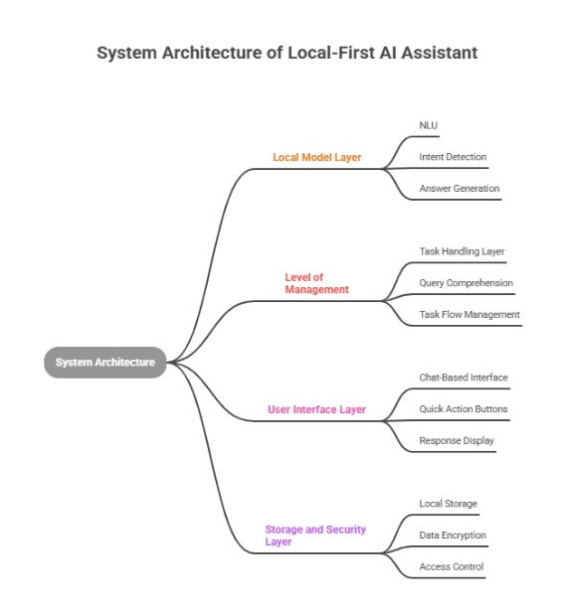

5. Core Functional Modules

5.1 Smart File Search & Retrieval

Module Description: The Smart File Search and Retrieval module enables users to search and retrieve their local device files through natural language queries. In traditional methods of file search, a user has to remember either the exact file name or location, which is, often very time-consuming and counterproductive. This module analyzes user intent and extracts pertinent keywords from queries using the on-device language model. In order to produce results that match, it will also search the device storage for documents, PDFs, notes, and other file types. Filters like date, file type, and relevance ranking are supported. Coupled with the ability for semantic search, the module enhances productivity and saves customers time finding critical documents without depending on any cloud-based search services.

5.2 Document Summary

The feature of Document Summary is developed and intended to deal with larger documents and provide a summary of the key points of the document. Users are often required to quickly comprehend large documents such as articles or study materials. Using the local language model, the module reads the document and presents a logical synopsis of its main ideas. A number of file formats, such as TXT, DOCX, and PDF, are also supported by the feature. Document summary allows users to concentrate on key details by facilitate the understanding of long documents. Being a local feature, it also provides privacy to the users as it does not need to host documents on the cloud.

5.3 Notes Organization and Quick Actions

This module assists users in note management by identifying and classifying notes according to topics, keywords, and tags. Quick actions such as setting a reminder for notes, sharing notes, editing their content, and creating to-do lists will also be facilitated. Users can create, edit, and arrange their notes in structured form, which would help them easily recover information anytime. The module will provide smart suggestions that can include the summarizing of notes or preparation of study schedules. By integrating quick actions, the assistant ensures productivity and makes note managing easier, with convenience for students and professionals alike.

5.4 Workflow Automation (Offline)

The Workflow Automation module will help the user in automating time-consuming tasks without depending on an internet connection. Organizing files into folders, scheduling routine tasks, sending automated alerts, and establishing time or location-based reminders are a few examples of this. The rules for these actions can be manually define by the user or reason by the assistant over time, based on patterns in user behavior. Since the assistant On-device, these automations work offline and hence are more dependable Without internet dependency. By automating routines that take up a great amount of time and effort, this module will help reduce manual work, save time, and enhance overall effectiveness.
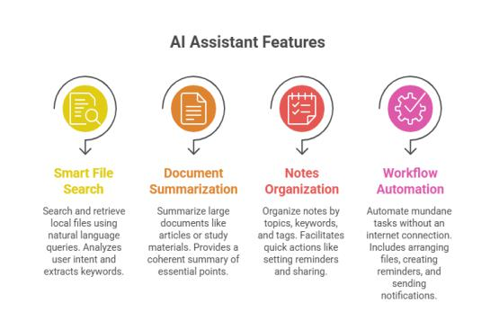

- Model Integration and Offline Inference

6.1 Ollama

Ollama is an on-device language model that is lightweight and facilitates off-line execution. The addition of Ollama makes it possible for the assistant to comprehend and express text without relying on the cloud.

6.2 On-Device

The pipeline for the inference consists of the preprocessing of the input from the user, the local execution of the model, and the postprocessing of the resultant output. All the aforementioned operations are carried out locally, which takes care of the low latency of the function.

6.3 Resource Optimization

For it to function properly on the cell phone, it is also tweaked using various techniques such as quantization and pruning. This ensure that it consume less memory and CPU resources, Upgrading the assistant for power efficiency.

7. Privacy & Data supremacy

7.1 Local Data Processing

The entire processing of user data takes place on the device, meaning that no personal user data is shared with third-party servers. The result is improved privacy coupled with minimal leakages of sensitive user data.

7.2 Encryption & Access Control

Encrypted local data accessible only via authorized user authentication.

7.3 User Ownership

Users have complete control of their data, including the ability to delete or control their data whenever they want.

8. Evaluation & Results
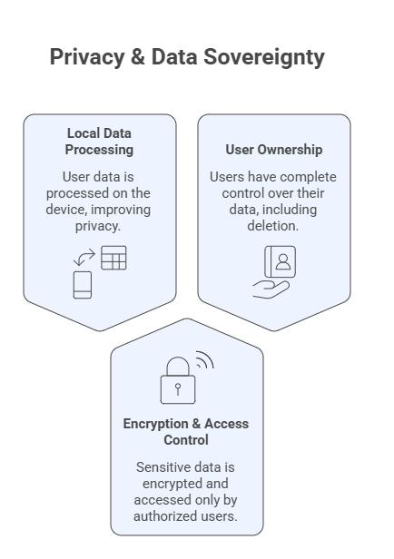

8.1 Performance - Speed & Memory

The system is assessed in terms of response time and memory usage. On-device processing shows lower latency compared to cloud-based assistants, while acceptable memory consumption is returned for mobile devices.

8.2 Accuracy & Reliability

Accuracy: This could be defined in terms of task success rate, such as obtaining the correct file after retrieval or summary relevance. The reliability for regular day-to-day activities is spot on, while for more complex queries that may require further optimization of the model.

8.3 User Experience User feedback shows

increased privacy, with quicker responses. Users feel empowered regarding their personal information.
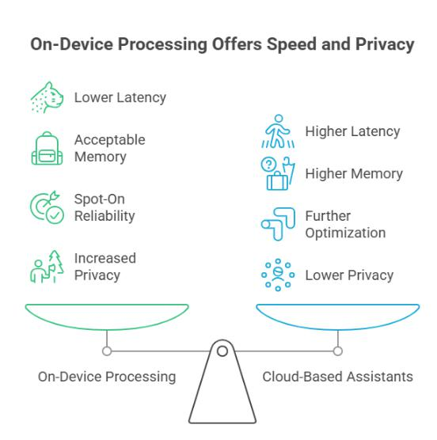

powered task automation can be integrated to improve functionality.
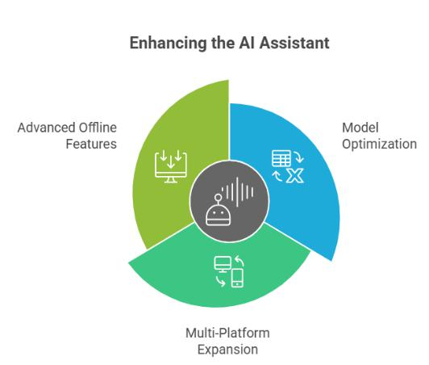

9. Future Scope

9.1 Model Optimization

The future research can involve methods such as model reduction techniques of quantization and pruning to make the assistant even faster and mobile-friendly.

9.2 Multi-Platform Expansion

The system is capable of operating on multiple platforms/environments (Android, iOS, desktop), which would ensure the local-first experience is consistent across devices.

9.3 Advanced Offline Features

Functionalities like: offline voice recognition functionality, real-time translation capabilities, and AI
10. Conclusion

The work offers a local-first approach for an AI assistant that functions only within the user’s device, resolving some critical drawbacks in cloud-based assistants, including privacy, internet connectivity, and ownership of user data. The proposed assistant uses the power of local language models and offline inference networks, making sure that any user data does not leave the device, thus promoting considerably more secure access for the user.

Key prominent features such as intelligent file search, summarization for documents, management for notes, and offline automation for tasks are integrated into the proposed architecture for a real-world application setup. It is observed that the system architecture with its layers like the model layer, task management layer, UI layer, and security layer helps in efficient coordination and
scalability with enhanced usability features. Performance analysis reveals faster execution with acceptable resource utilization with on-device execution in contrast to cloud-based assistants for performing tasks with reasonable accuracy.

Second, in addition to its performance advantages, a local first solution encourages autonomy and data self-sovereignty. Users are able to control, handle, and delete their data independent of other servers and policies. This transparency helps establish trust for users concerned about data security and privacy. In summary, the local-first AI assistant represents an effective alternative to the traditional cloud assistant. With further optimizations and the incorporation of more offline features, it can transform into an effective and trustworthy personal assistant for modern devices in terms of balancing intelligent features and privacy protection.

References

- Li, M., Xu, Z., & Chen, Y. (2020). Edge AI: On-Device Intelligence, Challenges, and Applications. arXiv Preprint.
- Dhumal, A., Yadav, V., Dhere, A., & Bagal, N. (2024). AURA – The Privacy Preserving Multifunctional Desktop Voice Assistant. International Journal of Research in Applied Science & Engineering Technology.
- Nguyen, K., Smith, J., & Wang, L. (2024). Evaluating Privacy, Security, and Trust Perceptions in Conversational AI: A Systematic Review. Computers in Human Behaviour Journal.
- Kleppmann, M., et al. (2019). Local-First Software Design Principles. Communications of the ACM.
- Buxmann, P., Hess, T., & Lehmann, R. (2019). AI-Based Digital Assistants: Opportunities, Threats, and Research Perspectives. Business & Information Systems Engineering.
- Wachter, S., & Mittelstadt, B. (2021). Data Protection and Privacy in AI-Driven Assistant Systems. AI & Society Journal.
- Misra, M. K. (2022). On-Device AI for Privacy-Preserving Mobile Applications Using Lightweight Models. International Journal of Computer Applications.
- Gupta, A., & Sharma, S. (2023). Efficient Deployment of Language Models on Edge Devices. IEEE Access.
- Amazon faces class-action over Alexa privacy — Reuters. (2025). Retrieved from https://www.reuters.com/legal/litigation/amazon-must-face-us-class-action-over-alexa-users-privacy-2025-07-07/?
- Amazon Echo privacy change — AP News. (Year). Retrieved from https://apnews.com/article/7fb3c19fa7f664bde5c5be259f8b23ee?
- Privacy threats in voice assistant apps — ScienceDirect. (Year). Retrieved from https://www.sciencedirect.com/science/article/pii/S0167404823003589?
- Privacy concerns in AI assistants (comparative study) — ResearchGate. (Year). Retrieved from https://www.researchgate.net/publication/385289571_Privacy_confidentiality_and_ethical_concerns_in_audio_ai_assistants_A_comparative_study_of_North_American_European_and_Asian_Markets?
- Cloud security breach overview — Reco.ai. (2025). Retrieved from https://www.reco.ai/blog/ai-and-cloud-security-breaches-2025?

